Mateusz Krzykowski 204211

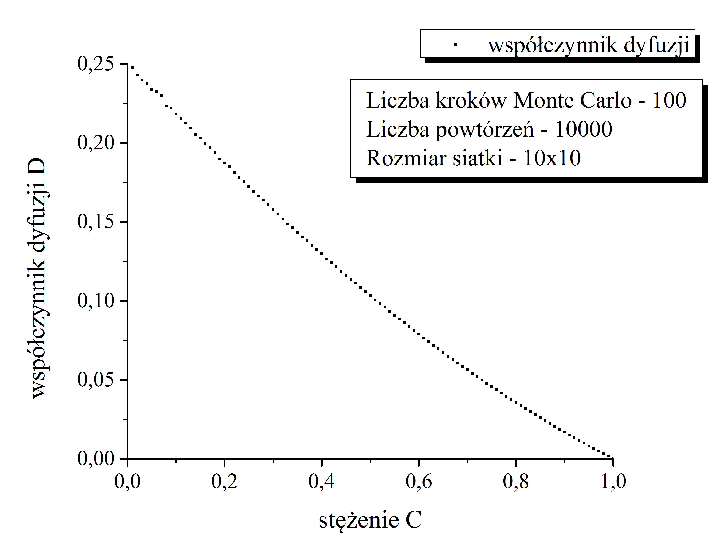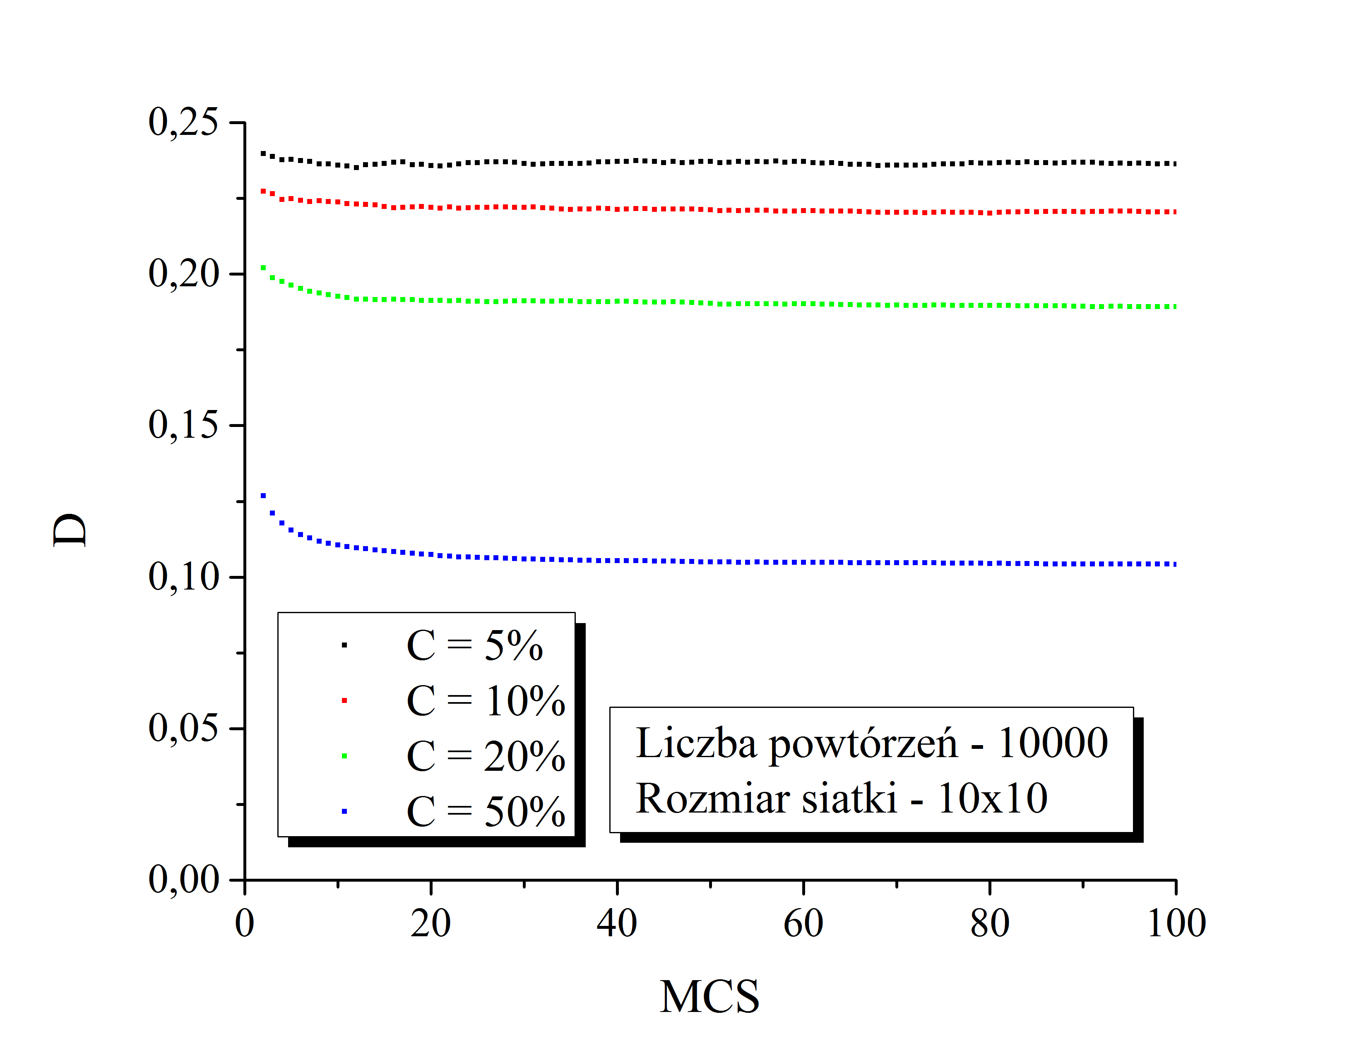

# Libraries import

import numpy as np

import matplotlib.pyplot as plt

from scipy import stats

class atom:

# Class defining atoms used in simulation

# Initialize object

def __init__(self, r):

self.r = np.array(r)

self.deltar = np.array([0, 0])

# Calculate diffusion coefficient D

def D(self):

return np.sum(np.power(self.deltar, 2))

L = 10 # Length of the 2D map

L2 = L ** 2 # Number of sites in the map

d = 2 # Dimentionality

nrepeat = 10000 # Number of repeats

random = np.random.randint # Assign random function

tmax = 100

LEFT = np.array([-1, 0])

RIGHT = np.array([1, 0])

UP = np.array([0, -1])

DOWN = np.array([0, 1])

randomstep = [LEFT, RIGHT, UP, DOWN]

def output(A, filename):

# Output [x, y] vector for output.txt file

f = open(filename, 'w')

for i in A:

f.write(str(i[0]) + " " + str(i[1]) + "\n")

f.close()

def output2(A, filename):

# Output [x, y] vector for output.txt file

f = open(filename, 'w')

for i in A:

f.write(str(i) + "\n")

f.close()

DofC = []

# Main loop

for N in range(1, L2):

is_graph = N in [5, 10, 20, 50]

c = N / L2

DofC.append([c, 0.0])

print("c = " + str(int(c * 100)) + "%")

graph = np.zeros((nrepeat, tmax))

for a in range(nrepeat):

points = set() # Initialize set of points

# Generate N points

for i in range(N):

while True:

A = (random(L), random(L))

if not A in points:

points.add(A)

break

items = [atom(point) for point in points] # Generate array of atoms

result = [] # Initialize results array

# Loop over MCS

for t in range(1, tmax):

for item in items: # Loop over atoms

deltar = randomstep[random(4)]

r = (item.r + deltar) % L

if not tuple(r) in points:

points.remove(tuple(item.r))

points.add(tuple(r))

item.r = r

item.deltar += deltar

if is_graph:

graph[a, t] += item.D() / t

# Append calculatedD to DofC list

DofC[-1][1] += np.sum(np.array([i.D()

for i in items])) / tmax / N / 4.0 / nrepeat

if is_graph:

graph = np.average(graph, axis=0) / N / 2.0 / d

output2(graph, 'output_N = ' + str(N) + '.txt')

DofC.append([1, 0])

output(DofC, 'output.txt') # Print D of c